**ASSIGNMENT -6**

**Grep Assignment**

1. **Use any .c file. Using grep command extract and display** 
   1. **all lines beginning with #include with line numbers**

To extract and display all lines beginning with ‘#include’ along with their line numbers, we use ‘grep’ command.

* ‘-n’ option is used to display line numbers along with the lines.
* ‘^#include’ specifies that you want to find lines starting with ‘#include’.

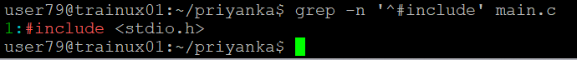

* 1. **display all lines which do not begin with #include**

To display all lines that do not begin with ‘#include’, we use ‘grep’ command.

* ‘-v’ option tells ‘grep’ to display lines that do not match the pattern.

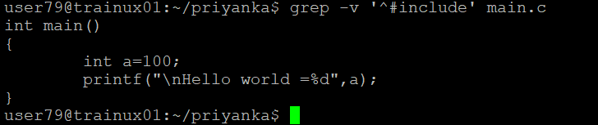

* 1. **display the line number of main ()**

To display the line number of the ‘main ()’ function, we use ‘grep’ command.

* ‘main ()’ is the pattern we are searching for.



* 1. **extract all lines containing characters of opening and closing parathesis {(,)}**

To extract all lines containing opening and closing parentheses, we use ‘grep’ command.

1. **Perform the above operations on a set of *.c files**

* To display the line number of ‘main ()’ in all ‘.c’ files, we use below command as shown in it.

* To display all lines not beginning with ‘#include’ in all ‘.c’ files, we use below command.

* To extract all lines containing opening and closing parentheses in all ‘.c’ files, we use below command.

